Take Me Home Country Roads Chords by John Denver

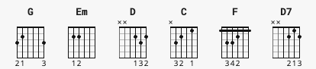

G Em D C G
Almost Heaven; West Virginia, Blue Ridge Mountains, Shenandoah River.
G Em D
Life is old there, older than the trees, younger than the mountains,
C G
Blowin' like a breeze.

[Chorus]

G D Em C
Country Roads, take me home, to the place, I belong,
G D C G
West Virginia, mountain mama, take me home, country roads.

[Verse 2]

G Em D C G
All my memories gather round her, miner's lady, stranger to blue water.
G Em D
Dark and dusty, painted on the sky, misty taste of moonshine,
C G
Teardrop in my eye.

[Chorus]

G D Em C
Country Roads, take me home, to the place, I belong,
G D C G
West Virginia, mountain mama, take me home, country roads.

[Bridge]

Em D G
I hear her voice in the morning hour she calls me,
C G D
The radio reminds me of my home far away.
Em F C
And driving down the road I get a feeling
G D D7
That I should have been home yesterday, yesterday.

[Chorus]

N.C. G D Em C
Country Roads, take me home, to the place, I belong,
G D C G
West Virginia, mountain mama, take me home, country roads.
G D Em C
Country Roads, take me home, to the place, I belong,
G D C G
West Virginia, mountain mama, take me home, country roads.
D G D G
Take me home, down country roads; take me home, down country roads

