**Exit Music For A Film Chords by Radiohead**

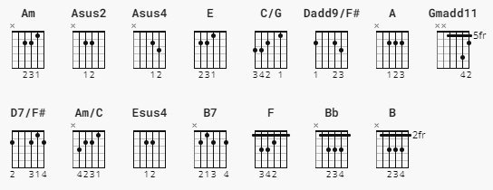

Capo 2nd fret

[Intro]

Am Asus2 Asus4

Am Asus2 Asus4

Am

[Verse 1]

Am E C/G Dadd9/F#

wake from your sleep, the drying of your tears,

Am E Asus4 A

today we escape, we escape

Am E C/G Dadd9/F# Dadd9/F

pack and get dressed, before your father hears us,

Am E Asus4 A

before all hell breaks loose

[Chorus]

Gmadd11 D7/F#

breathe, keep breathing

Asus2 Am Asus2 Asus4 Am/C Esus4

don't lose your nerve

Gmadd11 D7/F#

breathe, keep breathing

Asus2 Am Asus2 Asus4 Am/C Esus4 E

I can't do this alone

[Verse 2]

Am E C/G Dadd9/F#

Sing us a song, a song to keep us warm

Am E Asus4 A

there's sucha chill, sucha chill

[Bridge]

**Am** **B7** **E** **F** **Bb**

And you can laugh, a spineless laugh, we hope your rules and

**Esus4** **E**

wisdom choke you

[Outro]

**Am** **E** **C/G** **Dadd9/F#** **Dadd9/F**

And now we are one, in everlasting peace,

**Am** **E** **Asus4** **A**

We hope that you choke, that you choke

**Am** **E** **Asus4** **A**

We hope that you choke, that you choke

**Am** **E** **Asus4** **A**

We hope that you choke, that you choke

Chords:

**Am** (x02210)

**Asus2** (x02200)

**Asus4** (x02230)

**E** (022100)

**C/G** (332010)

**Dadd9/F#** (2x0230)

**Dadd9/F** (1x0230)

**Gmadd11** (3x0313)

**D7/F#** (2x0212)

**Esus4** (022200)

**B** (x2444x)

**F** (133211)

**Bb** (x1333x)

**A** (x02220)