Other Side Of The World Chords by KT Tunstall

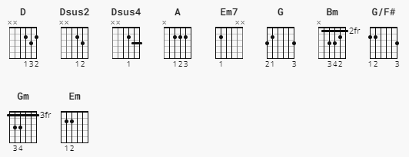

[Intro]

D Dsus2 Dsus4 Dsus2

[Verse 1]

A Em7

over the sea and far away

A

she's waiting like an iceberg

Em7

waiting to change

A

but she's cold inside

G

she wants to be like the water

D Dsus2 Dsus4 Dsus2

A Em7 A

all the muscles tighten in her face

Em7 A

buries her soul in one embrace

G

they're one and the same

just like the water

[Chorus]

D Bm

the fire fades away

G

most of every day

G/F# Em7

is full of tired excuses

A D

but it's too hard to say

Bm

i wish it was simple

G

but we give up easily

G/F# Em7 A

you're close enough to see that

Bm A G A

you're the other side of the world to me

D Dsus2 Dsus4 Dsus2

[Verse 2]

A Em7

on comes the panic light

A Em7

holding on with fingers and feelings alike

A

but the time has come

G

to move along

[Chorus]

D Bm

the fire fades away

G

most of every day

G/F# Em7

is full of tired excuses

A D

but it's too hard to say

**Bm**

i wish it was simple

**G**

but we give up easily

**G/F#** **Em7** **A**

you're close enough to see that

**Bm** **A** **G** **A**

you're the other side of the world to me

[Bridge]

**Em7**

can you help me

**Gm** **D** **Dsus2** **Dsus4** **Dsus2**

can you let me go

**Em** **Bm**

and can you still love me

**A** **G** **G/F#** **Em7** **D**

when you can't see me anymore

[Chorus]

**D** **Bm**

the fire fades away

**G**

most of every day

**G/F#** **Em7**

is full of tired excuses

**A** **D**

but it's too hard to say

**Bm**

i wish it was simple

**G**

but we give up easily

**G/F#** **Em7** **A**

you're close enough to see that

**Bm** **A** **G** **A**

you're the other side of the world to me

**D** = XX0232

**Dsus2** = XX0230

**Dsus4** = XX0233

**A** = x02220

Em7 = 02203(3) -sometimes with and sometimes without 3 on Estring

**Bm** = X24432

**G** = 320033

**G/F#** = 200233

**A** = X02220