Summer of 69 Chords by Bryan Adams

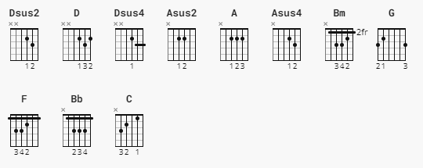

[A]

Dsus2 D Dsus4 D Dsus2 D

e|---0------2----3-----2-----0-----2----------|

B|--------------------------------------------|

G|--------------------------------------------|

D|-0-----0----0-----0--------0-----0----------|

A|--------------------------------------------|

E|--------------------------------------------|

[B]

Asus2 A Asus4 A Asus2 A

e|--------------------------------------------|

B|---0------2----3-----2-----0-----2----------|

G|--------------------------------------------|

D|--------------------------------------------|

A|-0-----0----0-----0--------0-----0----------|

E|--------------------------------------------|

[A] [B]

i got my first real six string - bought it at the five & dime

[A] [B]

played it til my fingers bled - was the summer of '69

[A] [B]

me and some guys from school - had a band and we tried real hard

[A] [B]

jimmy quit and jody got married - shoulda known we'd never get far

(Play with bar chords, can play with open chords)

Bm A D G

but when i look back now - that summer seemed to last for ever

Bm A D G

and if i had the choice - ya i'd always wanna be there

Bm A [A] [B]

those were the best days of my life

[A] [B]

ain't no use complaining - when ya gotta job to do

[A] [B]

spent my evenings down at the drive in - and that's when i met you - ya

Bm A D G

standing on your mamma's porch - you told me that you'd wait forever

Bm A D G

and when you held my hand - i knew that it was now or never

**Bm** **A** [A] [B]

those were the best days of my life - back in the summer of '69

(Play with bar chords for best results)

**F** **Bb**

man we were killin' time

**C** **Bb**

we were young and reckless - we needed to unwind

**F** **Bb** **C** [A] [B]

i guess nothing can last forever...

[A]

and now the times are changin'

[B]

look at everything that's come and gone

[A]

sometimes when i play my old six string

[B]

i think about you wonder what went wrong

**Bm** **A** **D** **G**

standing on your mamma's porch - you told me that you'd wait forever

**Bm** **A** **D** **G**

and when you held my hand - i knew that it was now or never

**Bm** **A** [A] [B] continuous till end

those were the best days of my life - back in the summer of '69